SMART CAR

by

Arul and Nishad

INDEX

INTRODUCTION
- Purpose and Scope
- Scope of software implementation work includes
- Basic functionality and implementation of the following activities.
- Glossary

Requirement Specification Overview
- Components

Development Environment

Software overview
- Driving mode
- Parking mode

Major Integrations
- Integrating an ultrasonic sensor with PWM functionality on a Character LCD (CLCD) with Raspberry Pi
- Integrating DC motor and servo motor with a Character LCD (CLCD) with PWM functionality using Raspberry Pi
Testing Overview

Assumptions and Data

Requirement Specification Details
- Booting Requirements
- Communication & Interface Requirements
- Linux application Requirements

FUTURE SCOPE

INTRODUCTION

Purpose and Scope

Purpose of this document is to describe the software requirements for Raspberry Pi demonstration Project – Autonmous Car Project

Scope of software implementation work includes:

Raspberry pi 2b+ v1.2
- Multi Module integration and verification
- Driver customization activities for the following modules:
- Implimenting Switch with the funcationality of a trigger or ‘Ignition’.
- SG90 miniature servo motor position control using PWM. It simulates the steering wheel on a car.
- Implimenting Light Detection Sensor for automatic switching the light based on brightness.
- PWM DC motor speed control using GPIO with respet to predefined instrcutions
- Implementing CLCD with the functionality of a dashboard on a car, it displays the current selection and the Directions.
- DC motor runs with reduced duty cycle to simulate the parking processor
- Ultrasonic Sensor will be implemented to sense the wall and provide analog measurement to warn the driver about the distance between the car and wall.
- Implementing Buzzer that is sensitive to threshold defined for parking distance.
Implimenting LED to visualize the PWM functoinality
- Interrupt driven measurement from ultrasonic sensors and realtime display on CLCD.
Basic functionality and implementation of the following activities:
- Application of Raspberry PI libraries.
- Implimenting Devices and peripherals with their drivers.
- interfacing components with raspberry PI.
- Troubleshooting and customising peripherals.
- Integration and Testing with Simulated Data.

Glossary

Acronyms | Description
4G | Fourth Generation Network
SATA | Serial Advanced Technology Attachment
SPI | Serial Peripheral Interface
USB | Universal Serial Bus
Wi-Fi | Wireless Fidelity
GPS | Global Positioning System
LowPAN | IPv6 over Low-Power Wireless Personal Area Networks

Requirement Specification Overview

Specification:

The scope contains Board bring up, device driver customization and basic test application development of Automated car system functionality.

- The car uses a Raspberry Pi for its brains... running code on multiple cores, using Raspberry PI libraries.

- Overall Linux software consists of boot loader (i.e. U-boot) which is used for board initialization and loading the OS, OS/kernel, which contains the OS as well as drivers and kernel configurations and file system.

- It includes the entire user level utilities and applications along with system libraries. Raspberry Pi has its own proprietary bootloader, which is loaded by the ROM code and is capable of loading the kernel

Components:

Raspberry Pi 2 Model B v1.2
- BCM2837 SoC
- quad-core 900 MHz ARM Cortex-A53 processor.
- 1 GB RAM
- 4 x USB 2.0 sockets
- 10/100 BaseT Ethernet socket
- HDMI video socket
- RCA composite video socket
- microSD card socket
- Powered from microUSB socket
- 3.5 mm audio out jack
- Header for GPIO and serial buses
- Display Serial Interface (DSI) 15 way flat flex cable connector with two data lanes and a clock lane
- Camera connector 15-pin MIPI Camera Serial Interface (CSI-2)

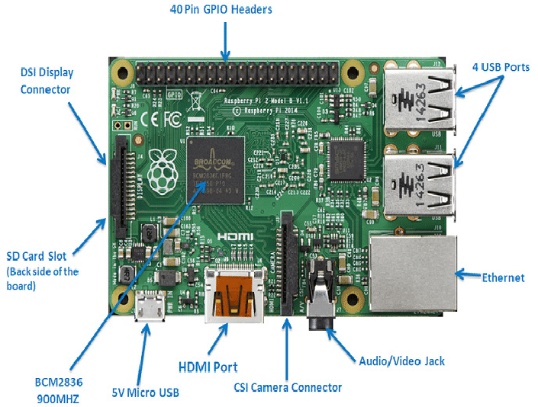

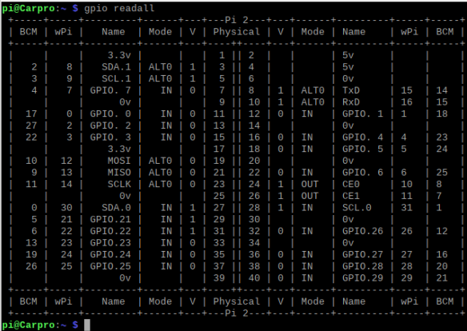

Development Environment:

Environment statistics for host machine:
Host PC | Ubuntu 20.04.05 LTS
Cross Compiler | Gcc-arm-none-eabi-4_9-2015q3
Linux Kernel | 5.15.0-60-generic
System clock cycle | 32-bit
Debian version | 11 (bullseye)
Debug port/Console | UART
Board Support Package | Raspberry PI Support SDK
Debugging Tools | PI In system debugger

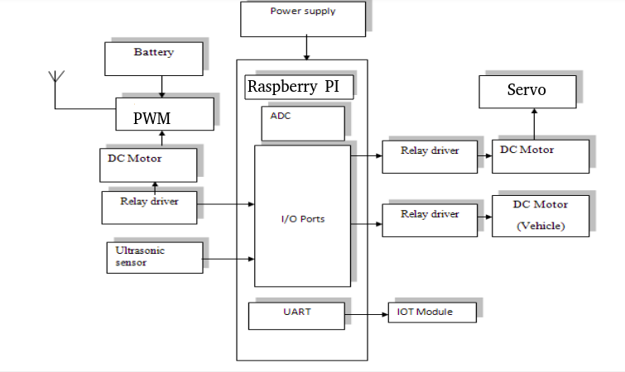

Software Overview
There are 2 major phases in software implementation:
Drive mode and parking mode are two different modes of operation that can be implemented in a smart car project.
DRIVING MODE
Drive mode: In this mode, the car is driven autonomously.
- When the car is in drive mode, the Raspberry Pi is responsible for controlling the motor and other necessary components.
- Components like steering (Servo Motor), acceleration and braking (DC Motor). In autonomous driving mode, the Raspberry Pi uses CLCD to display (or act as a Dashboard).
- The car would follow (Display on CLCD) the current chosen path and have relative PWM feedback.

PARKING MODE
Parking mode: In this mode, the car is parked and the Raspberry Pi is responsible for monitoring the surroundings to detect any obstacles, such as pedestrians or other vehicles, and assist with parking maneuvers.
- The Raspberry Pi can use ultrasonic sensors, LDR sensor, or other sensors to detect the distance between the car and surrounding objects.
- Provide visual or auditory feedback (Buzzer warning and LED with increasing intenisty of its glow) to the driver to assist with parking.
To implement these modes in a smart car project, integration of the necessary sensors and hardware components into the system to enable autonomous driving and parking is done. Additionally, the system is tested and refined to ensure it operates safely and reliably in both modes.

MAJOR INTEGRATIONS

Integrating an ultrasonic sensor with PWM functionality on a Character LCD (CLCD) with Raspberry Pi :
- Hardware setup: Connect the ultrasonic sensor to the Raspberry Pi's GPIO pins, and connect the CLCD to the Raspberry Pi's GPIO interface. The datasheets can be reffered to specific sensor and display to identify the appropriate pins and connections.
- Software installation: Install necessary software libraries and dependencies for the ultrasonic sensor and CLCD.
- Code development: C programing is used that reads data from the ultrasonic sensor, calculates the distance to the nearest object, and adjusts the duty cycle of a PWM signal based on the distance. The PWM signal can be used to control the brightness of the LED. The program also displays the distance measurement and other relevant information on the CLCD.
- Testing: Test the program on the Raspberry Pi to ensure it operates as expected. You may need to adjust the PWM duty cycle and other parameters to optimize the performance of the system.

Integrating DC motor and servo motor with a Character LCD (CLCD) with PWM functionality using Raspberry Pi:
- Hardware setup: Connect the DC motor and servo motor to the Raspberry Pi's GPIO pins.
- A motor driver board or H-bridge to control the DC motor (L293D was used here), and a normal GPIO pin was used to control the servo motor.
- The CLCD to the Raspberry Pi is connected using its extended pins.
- Software installation: Install any necessary software libraries and dependencies for controlling the DC motor, servo motor, and CLCD.
- Code development: C program is written to control the speed of the DC motor using PWM signals, The reduced speed is in harmony with the Servo motor for the Direction control.
- The angle of the servo motor using PWM signals as well (~180 degree range with PWM range value of 45-150-245 respectively).
- The program also displays this information about the motor speeds and angles on the CLCD (STRAIGHT, LEFT and RIGHT).
- Testing: Test the program on the Raspberry Pi to ensure it operates as expected. You may need to adjust the PWM duty cycle and other parameters to optimize the performance of the system.
- The visual representation of the PWM is devices to run the LED.
- The PWM duty cycle becomes the input of the intensity of the GPIO used for LED.
Overall, integrating DC motor and servo motor with a CLCD with PWM functionality using Raspberry Pi requires careful hardware and software setup, along with code development and testing. The smart car can control motor speeds and angles, and display relevant information on a convenient and easy-to-read CLCD display.

TESTING OVERVIEW

Testing concepts and Deliverables of this implimentation.
Preper the driver module (Raspberry Pi), including an operating system such as Raspbian libraries or dependencies required by the specific autonomous car project.

- Connect the Raspberry Pi to the necessary hardware components and other necessary components for the project.
- Set up the Raspberry Pi to communicate with the hardware components, using GPIO pins or other methods depending on the specific hardware being used.
- Write and test code to control the hardware components and receive data from the sensors.
- Implementation and testing of the algorithms and logic is required for autonomous driving, such as obstacle Detection, distance detection, and trigger warnings.
- Testing the autonomous car project in a controlled environment, such as a test rack, to verify that the car simulation components behaves as expected.
- Continued testing and refining the components study until the total integration with defined reliability.
- The Visual indicators will work while demonstrating the signal transfer between the board and the peripherals.
- The Ultrasound feature can be used for detecting impending objects, we can use light indicators to warn about distance.
- The Ultra sound sensor will be the trigger to the warnings, so it will be used as the interrupt caller for an unexpected situation that may arise. Motors will have visual indication that will be the movement as a response to the input. We are using DC motors and servo motors for each purpose of their own.

- Pulse width Modulation (PWM) pins will be used for modulation or sensitive control of our motors asPulse width modulation or PWM is a commonly used control technique that generates analog signals from digital devices such as microcontrollers. In PWM technique, the signal's energy is distributed through a series of pulses rather than a continuously varying (analog) signal.

- The Visual indicators will work while demonstrating the signal transfer between the board and the peripherals.

- The Ultrasound feature can be used for detecting impending objects, we can use light indicators to warn about distance.

- The Ultra sound sensor will be the trigger to the warnings, so it will be used as the interrupt caller for an unexpected situation that may arise. Motors will have visual indication that will be the movement as a response to the input. We are using DC motors and servo motors for each purpose of their own.

- Pulse width Modulation (PWM) pins will be used for modulation or sensitive control of our motors asPulse width modulation or PWM is a commonly used control technique that generates analog signals from digital devices such as microcontrollers. In PWM technique, the signal's energy is distributed through a series of pulses rather than a continuously varying (analog) signal.

START
BUTTON
PRESSED
NO
YES
DRIVE MODE
Based on PATH selected
Rotating Servo shaft and running of Dc motor.
Select a Path
Path
Within
Range
NO
YES
Location Reached
Turning off servo and dc.
PARK MODE
Rotating DC motor backwards and measuring distance using Ultra sonic sensor
Dist < Thershold
NO
STOP
Stop dc motor, LED and Buzzer ON for 3 sec
Parked Successfully
YES

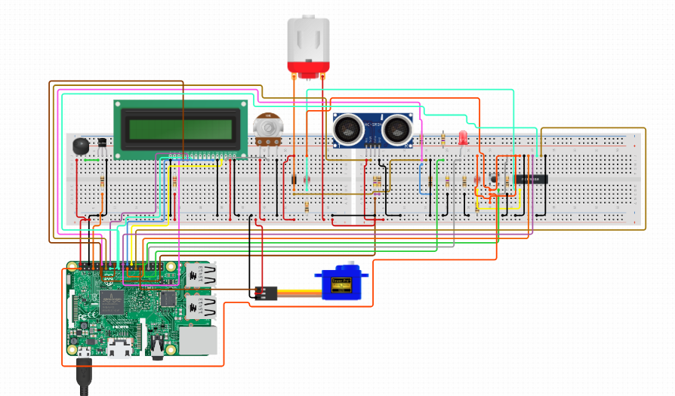

Layered Architecture

System Booting process for Raspberry Pi

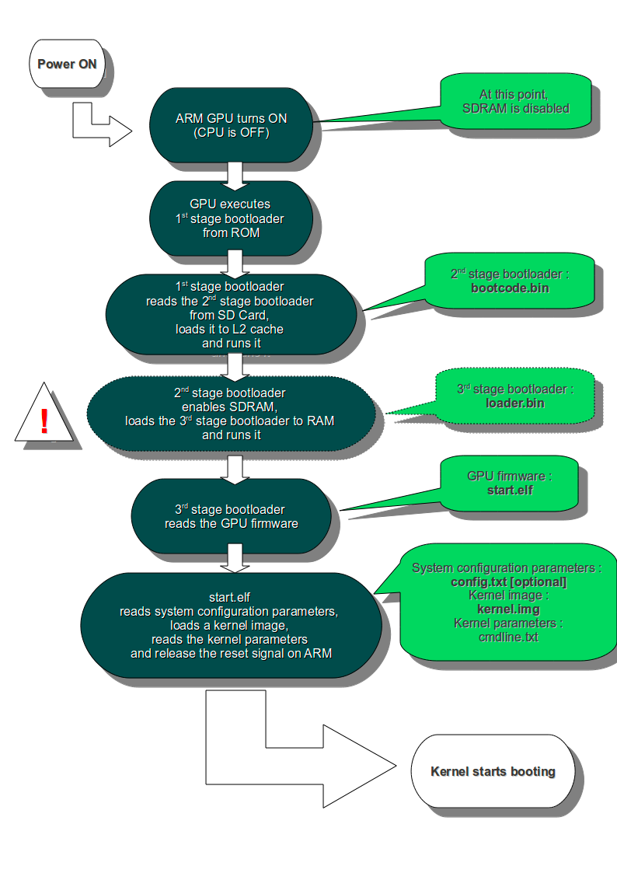
Assumptions and Data

Software Requirement

Linux Driver and Hardware Interface Requirements:

Requirement  ID | Requirement | Description | Customer Requirement | Hardware Interface, Dependencies,  Remarks (if any)
1 | Wi-Fi Driver | Wi-Fi Communication | Data transfer | This module can use interface type Wi-Fi.
2 | Ethernet streaming Module | Data Transmitted via Ethernet. | Data transfer between peripherals | This module can use interface Ethernet
3 | Ultra sound Sensor | UART | Data from sensor to serial display | To detect impending objects
4 | DC motor | GPIO interface | Polar terminals | Steering wheel and wheels of car
5 | Servo motor | GPIO interface | Polar terminals | Steering wheel
6 | CLCD screen | I2C protocol | Display Data from peripherals | Analysis and Diagnostics
7 | Raspberry PI 2B v1.2 | USB protocol | Single board Computing of peripherals | Main processor

Requirement Specification Details

Booting Requirements

Micro SD Card with Processor Specific Tool chain
Purpose
Raspberry PI Bullseye has its OWN BIOS, so OS will be configured and booted from SD card.

Communication & Interface Requirements
Latest stable Linux Kernel which is 5.15. is used.
Src: https://www.raspberrypi.com/software/operating-systems/

Wi-Fi Mesh Driver
Purpose
This driver is used to support the Ethernet protocol with Gigabit speed. The Ethernet MAC driver support data transfer to fixed IP address in mesh module.

Discrete I/O Interface
Purpose
This contains 2 to 3 Discrete I/O pins. Here for example application to read ADC output using the interface.

SPI
Purpose
This interface is required to support WAIC. SPI Driver should be made available.

Linux application Requirements

Wi-Fi transfer
Purpose
Data transfer among multiple modules. It can be used with sensors connectivity as well as Data transfer application.

GPIO transfer
A basic component of interface for modern microcontrollers with 2 voltage settings (High-Low)
FUTURE SCOPE

The implementation of a smart car project using Raspberry Pi and C programming has a lot of potential for the future. Some possible areas of development and improvement are:
- Autonomous driving: The integration of advanced sensors and machine learning algorithms could enable the smart car to navigate roads and traffic on its own.
- Connectivity: The smart car can be made more connected by integrating it with other IoT devices and cloud services, making it easier to control and manage remotely.
- Energy efficiency: The implementation of energy-efficient features such as regenerative braking and solar panels could significantly reduce the carbon footprint of the smart car.
- User interface: The development of an intuitive and user-friendly interface for controlling the smart car could improve the user experience and encourage wider adoption.
- Security: The implementation of advanced security features such as encryption and biometric authentication could improve the safety and privacy of the smart car and its occupants.
Overall, the future scope of the smart car project implemented with Raspberry Pi in C is vast and exciting, with numerous opportunities for innovation and advancement.

